Task 1
#include<iostream>
#include<string>
using namespace std;
int main ()
{
string date;
cout<<"Enter date (DD/MM/YY) i.e (05/03/2023): ";
cin>>date;

cout<<"\nThe date is "<<date.substr(0,2);
cout<<"\nThe month is "<<date.substr(3,2);
cout<<"\nThe year is "<<date.substr(6,4);

return 0;
}
OUTPUT
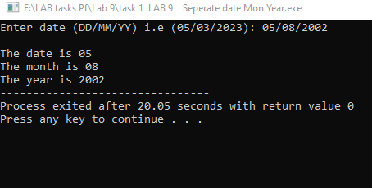
TASK 2.
#include<iostream>
#include<string>
using namespace std;
int WordCount(string line);
int main ()
{
string line;
cout<<"Enter any string ";
cout<<"Enter a string which must contain one space and have no space in last : ";
getline(cin, line);
int result=WordCount(line);
cout<<endl<<"The number of words in string is "<<result;

return 0;
}

int WordCount(string line)
{
int word=1;
for(int i=0; i<line.length(); i++)
{
if(line[i]==' ')
word+=1;
}
return word;
}
OUTPUT
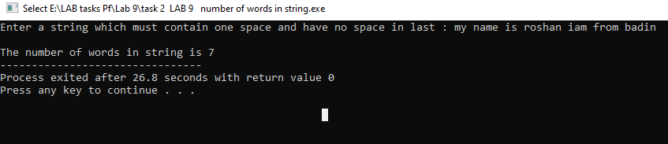

TASK 3
#include<iostream>
#include<string>
using namespace std;
int main ()
{
string number, network;
cout<<"The accepted networks are only (0300/0315/0333/0345) others are not accepted";
cout<<"\n\nEnter a phone number : ";
cin>>number;

network=number.substr(0,4);
if(network=="0300")
cout<<"Network is Moblink. ";
else if(network=="0333")
cout<<"Network is Ufone. ";
else if(network=="0315")
cout<<"Network is Zong. ";
else if(network=="0345")
cout<<"Network is Telenor. ";
else
cout<<"\nThe netwrok does'nt match to the requirement ";
return 0;
}
OUTPUT

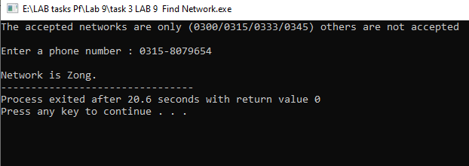

TASK 4
#include<iostream>
#include<string>
using namespace std;

int main ()
{
string email,FirstName,LastName;

cout<<"Enter your First name : ";
cin>>firstName;

cout<<"Enter your Last name : ";
cin>>lastName;

email=Firstname+"."+Lastname+"@iba-suk.edu.pk";
cout<<"Email Address is : "<<email;

return 0;
}

OUTPUT
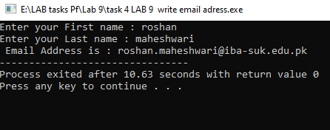

TASK 5
#include<iostream>
#include<string>
using namespace std;
string my_lower(string input);
int main ()
{
string str;
cout<<"Enter string value : ";
getline(cin,input);

string LowerCase=my_lower(str);
cout<<"Given string in lower case is : "<<LowerCase;

return 0;
}

string my_lower(string input)
{
string LowerCase;
for(int i=0; i<input.length(); i++)
{
if(input[i]>=65 && input[i]<97)
{
input[i]+=32;
LowerCase+=input[i];
}
else
LowerCase+=input[i];
}
return LowerCase;
}

OUTPUT
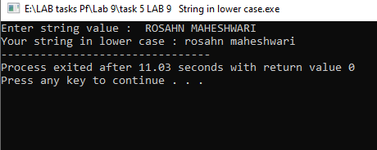

TASK 6
#include<iostream>
#include<string>
using namespace std;
string my_upper(string input);
int main ()
{
string str;
cout<<"Enter string value : ";
getline(cin,input);

string UpperCase=my_upper(str);
cout<<"Given string in Upper case : "<<UpperCase;

return 0;
}

string my_upper(string input)
{
string UpperCase;
for(int i=0; i<input.length(); i++)
{
if(input[i]>=97 && input[i]<=122)
{
input[i]-=32;
UpperCase+=input[i];
}
else
UpperCase+=input[i];
}

return UpperCase;

}
OUTPUT
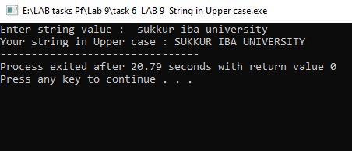

Task 7
#include<iostream>
#include<string>
using namespace std;
int main ()
{
string input, arr, arr2;
cout<<"Enter string value : ";
cin>>input;

for (int i=0; i<input.length(); i++)
arr+=input[i];

for(int j=input.length()-1; j>=0; j--)
arr2+=input[j];

if(arr==arr2)
cout<<"It is Palindrome";
else
cout<<"It's not a Palindrome";

return 0;
}

Output
